David Rimmer
tgkr2833

PHAS2000
Level 2 Coding Project Report

1.1: 10keV data
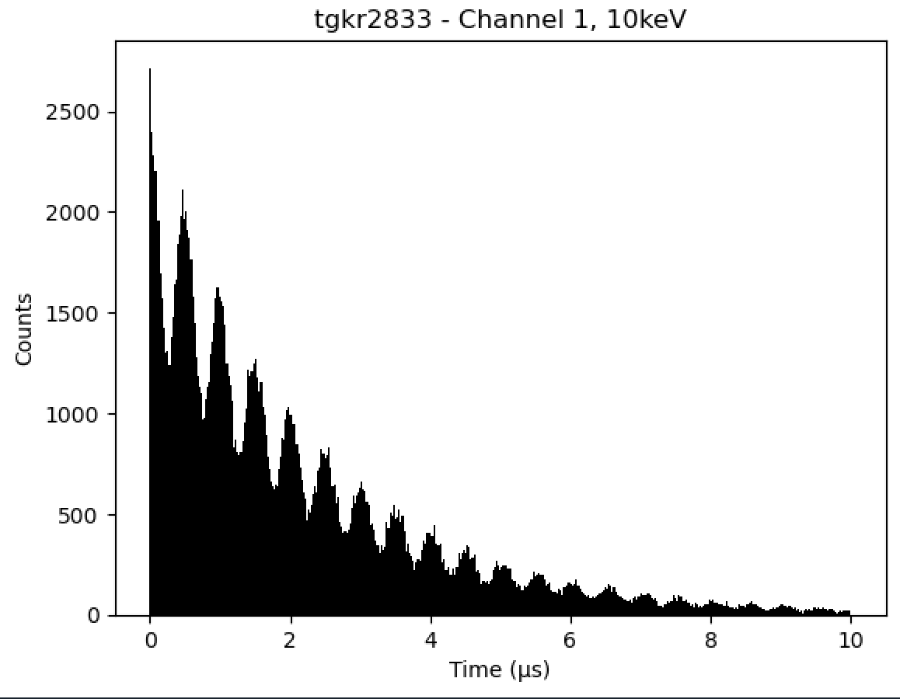
Figure 1: Histogram plot of the left channel for counts against time for 10keV with a bin number of the square root of the length of the data.

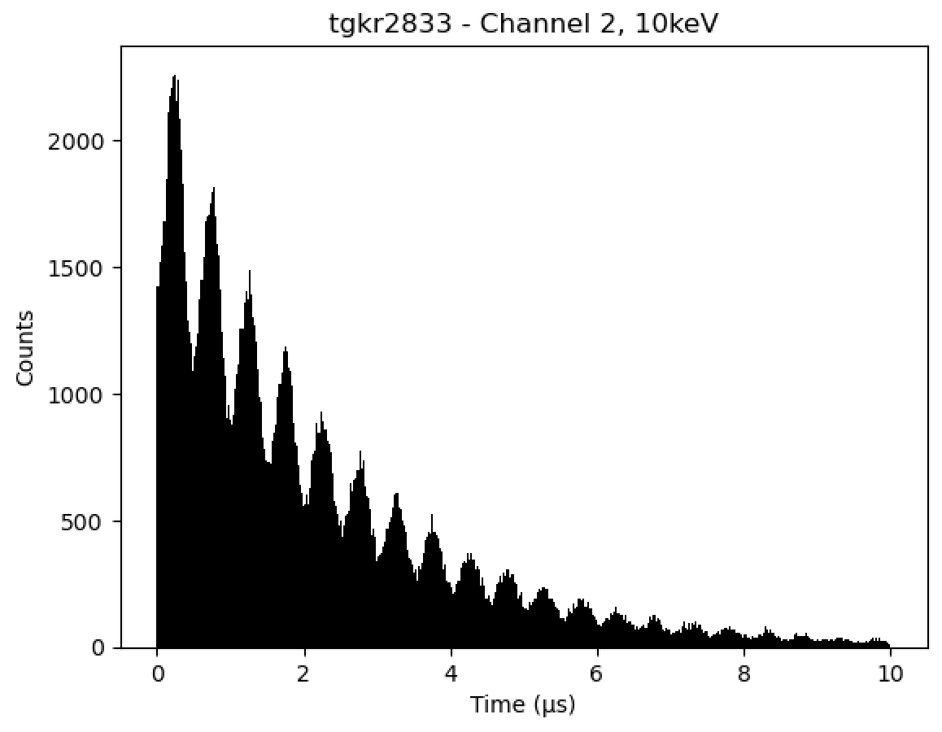
Figure 2: Histogram plot of the Right channel for counts against time for 10keV with a bin number of the square root of the length of the data.

1.2: Asymmetry plot
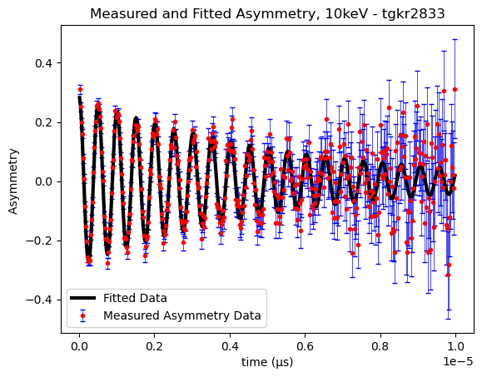
Figure 3: Plot of the measured asymmetry data and fitted asymmetry data with B = $0.014642±{8×10}^{-6}$ (Tesla), Beta = $0.94±0.04$ (Radians) and Tau = $5.3×{10}^{-6}±3×{10}^{-7}$ (seconds).

1.3: Table of Results
Table 1: Results of processing the assessment data file
Beta, $β$ (Radians): | $$0.94±0.04$$
Magnetic Field, B (T, Tesla): | $$0.014642±{8×10}^{-6}$$
Time Damping, $τ$ (s, Seconds): | $$5.3×{10}^{-6}±3×{10}^{-7}$$

2: Flowcharts
2.1: ProcessData() 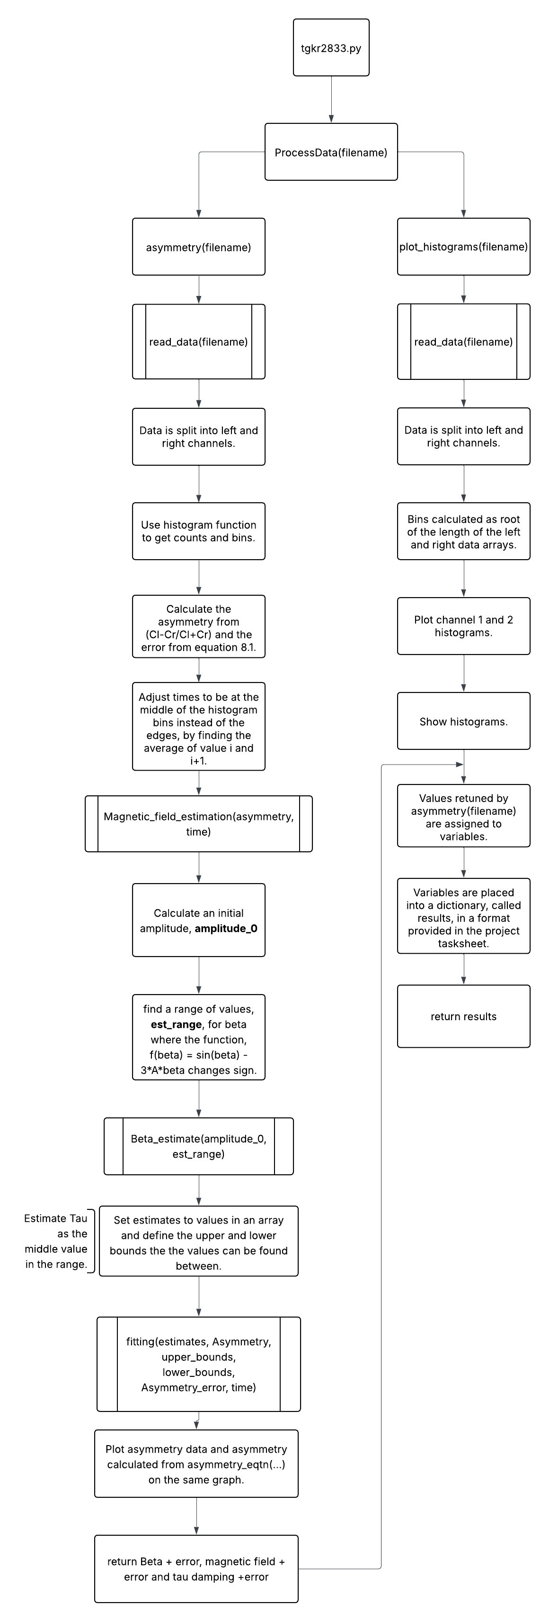

Figure 4: Flowchart of the function ProcessData()

2.2: read_data()
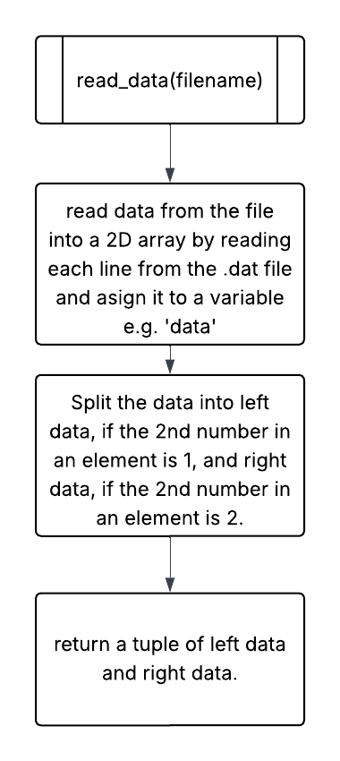
Figure 5: Flowchart of read_data()

2.3: plot_histograms()
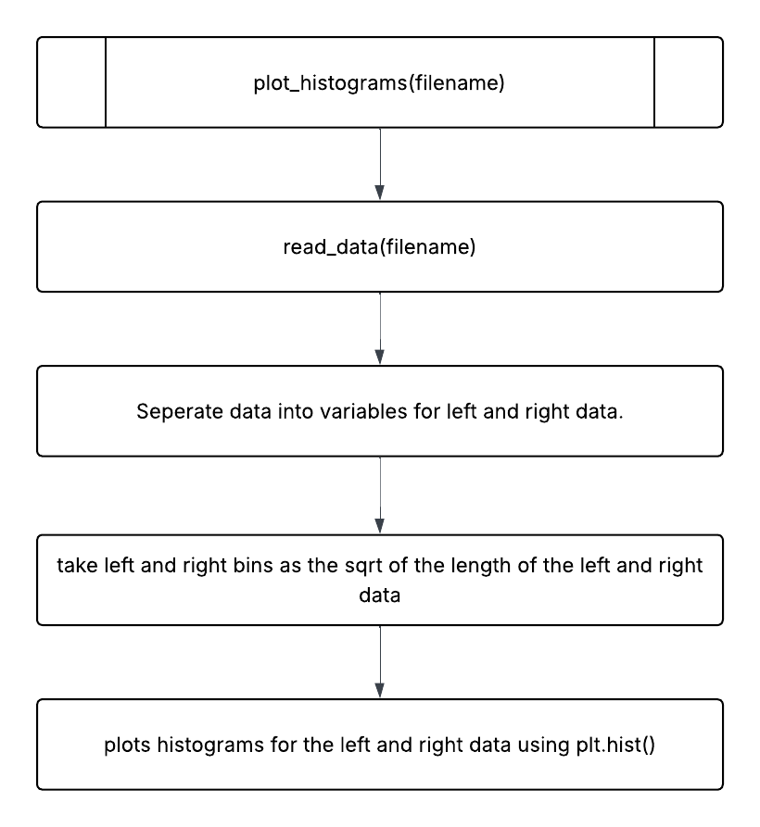
Figure 6: Flowchart of plot_histograms()

2.4: Magnetic_Field_Estimation()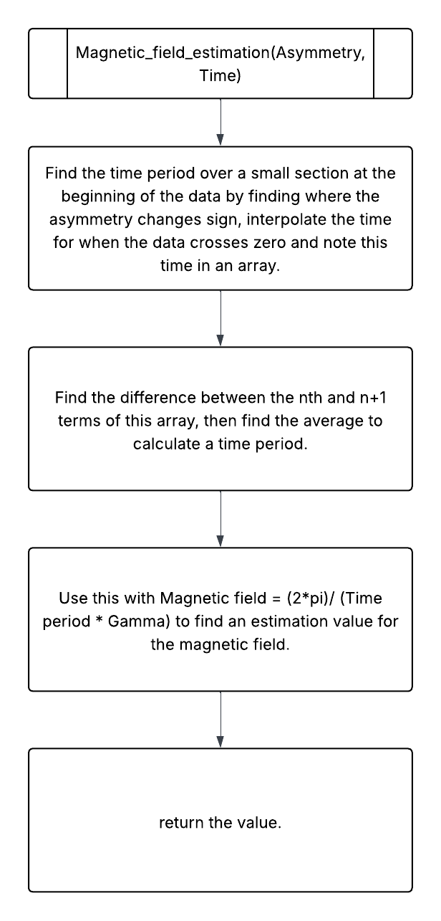
Figure 7: Flowchart of Magnetic_Field_Estimation()

2.5: asymmetry_equation()
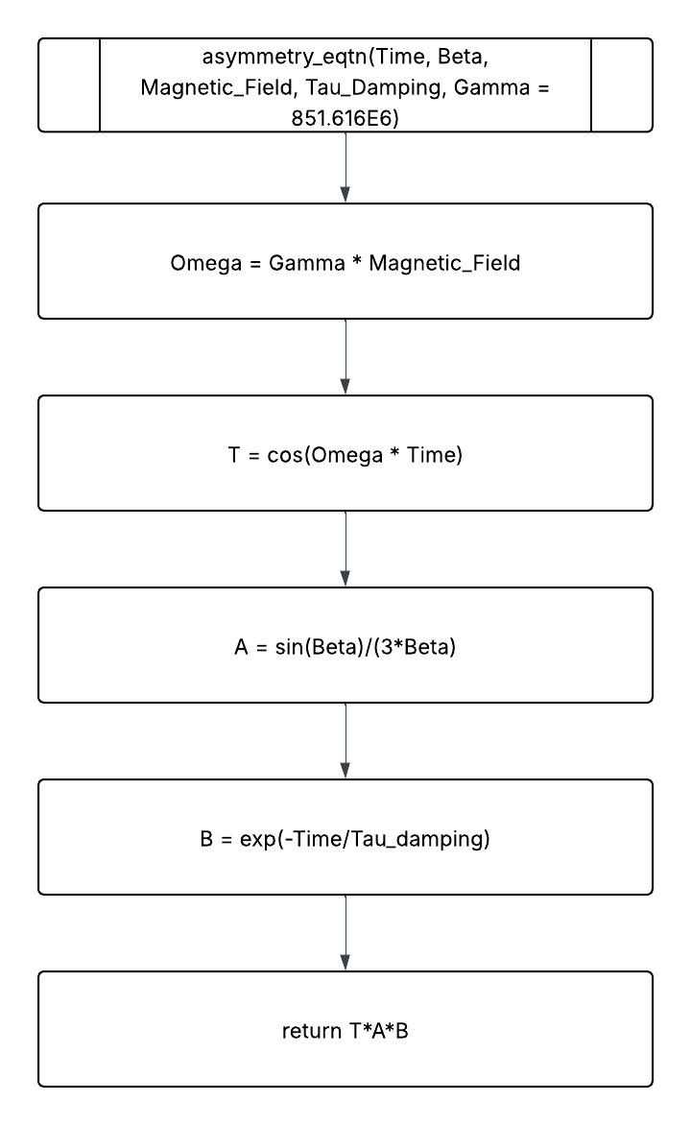
Figure 8: Flowchart of asymmetry_equation()

2.6: fitting()
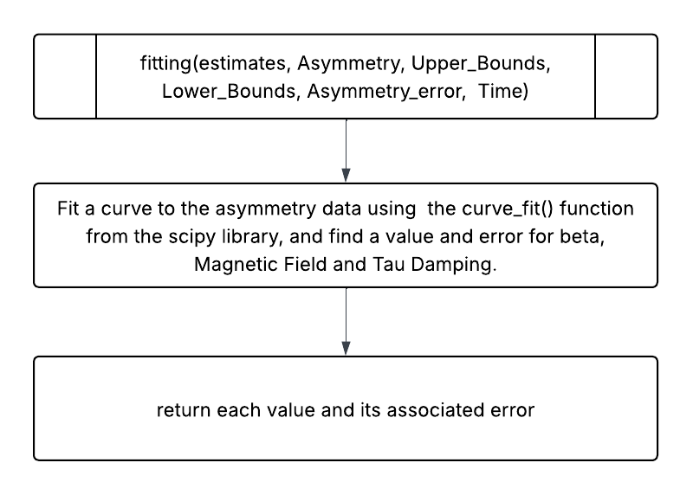
Figure 9: Flowchart of fitting()

2.7: Amplitude_eqtn()
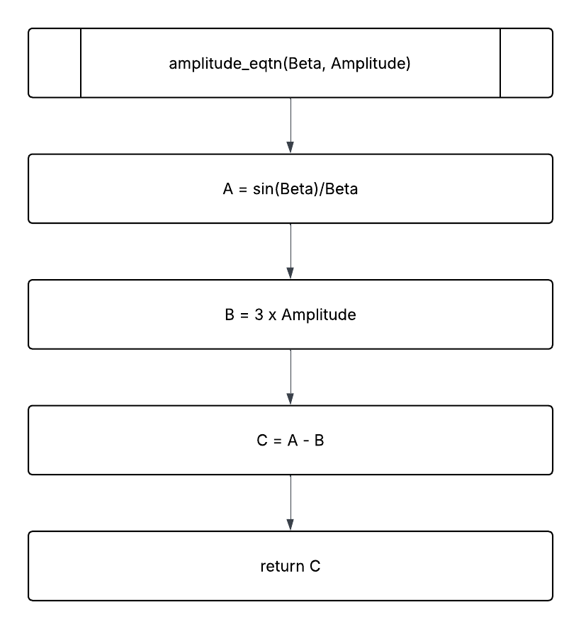
Figure 10: Flowchart of Amplitude_eqtn()

2.8: Beta_estimate()
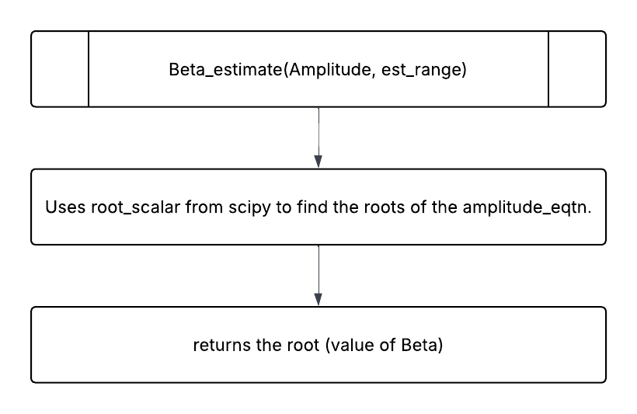
Figure 11: Flowchart of Beta_estimate()

